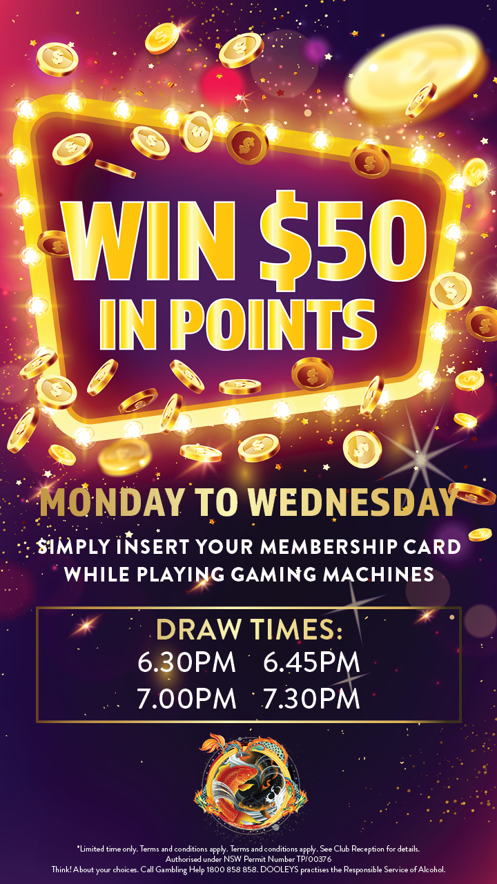


Terms & Conditions

WIN AN NRL CORPORATE BOX EXPREIENCE | LIDCOMBE AND REGENTS PARK

- Entry into the DOOLEYS win a NRL corporate box experience is open to eligible members of DOOLEYS as referred to in conditions five (5) and six (6) in DOOLEYS standard promotion conditions (the Standard Conditions).
- The Promotion period is from Monday 16 February 2026 at 10:00am to Sunday 29 March 2026 at 11:59pm.
- Eligible entrants will be issued one (1) entry when purchasing a Lion Nathan product from Baileys Bar or Lloyds Bistro Bar at DOOLEYS Lidcombe Catholic Club as well as the Main Bar or Alfresco bar at Regent St Pavilion.

- Participating Lion Nathan products include including Toohey’s New, Toohey’s Old, Hahn Super Dry, Hahn 3.5, Hahn Premium Light.

- RSP Branded Beer ‘Jack & Ale’ is not included.

- Members must produce their membership card during the transaction to receive an automatic entry into the draw. Payment forms can include cash, eftpos, credit or debit card, or DOOLEYS reward points.

- Eligible entrants will automatically be allocated one (1) entry ticket into the draw when purchasing a Schooner. Entry ticket will automatically go into the draw.

- Entries will represent the eligible Member’s name and Membership number and is not transferrable.

- Prizes are 2 x double passes to be won at Lidcombe and 2 x double passes to be won at Regent St Pavilion. Each pass includes a food and beverage package.

- The match is Parramatta Eels Vs West Tigers taking place at 4.05pm, Sunday 6 April at Commbank Stadium.

- Total Value of the prize is approximately $2000.

- Two winners to be drawn from DOOLEYS Lidcombe and two winners to be drawn from Regents Park.

- Winners will be selected at random by a DOOLEYS representative on Monday 30 March 2026. Winners will be notified by phone by a DOOLEYS representative. Only one member can be awarded a maximum of one Experience.

- Winners must present sufficient identification including their membership card to be eligible to claim the prize.

- If the prize goes unclaimed, or the winning entrant does not present within 24 hours of being notified, the prize will be forfeited and a redraw will occur.

Other Conditions
The Standard Conditions apply.

Standard promotion conditions (trade promotion lotteries)
- The Promoter. DOOLEYS Lidcombe Catholic Club Limited having its registered office at 17 Church Street, Lidcombe NSW 2141 phone 8745 6100 (Club) is the promoter of any trade promotion lottery promotion (Promotion) run in the Club's name with the approval of the Club.
- Conditions and Specific Conditions. These conditions apply to each Promotion (Conditions) along with the specific particular conditions (the Specific Conditions) with details of the particular Promotion and detailing information about and how to enter the Promotion (Specific Conditions), which form part of the Conditions for that Promotion. Any other information or advertising provided by the Club in relation to the Promotion is of a general nature only: for the full details, the Conditions should be consulted in full, and where there is any inconsistency, the Conditions prevail. If there is any remaining ambiguity in the Conditions, then the Club acting in good faith has the right to decide how to resolve the ambiguity, without needing to consult with anyone or provide reasons and the Club's decision in that regard is final.
- Permits and Promotion Period. The relevant NSW trade competition permit for the Promotion and any period for the Promotion (Promotion Period) are as recorded in the Specific Conditions.
- Specific Rules. By entering the Promotion, you accept the Conditions which include any conditions set out in the Specific Conditions for the Promotion. If there is any inconsistency, then the Specific Conditions prevail to the extent of the inconsistency.
- Eligibility. You may only enter the Promotion if you are a financial Ordinary, Life or 30 Year Member or a provisional Member, during the Promotion including throughout the Promotion Period and up to the time that you seek to receive any prize, award or benefit in connection with the Promotion. That is an essential condition. That means that the minimum age for participation is 18. Honorary or temporary members may not participate. You lose the right to participate if you are suspended or expelled or if your membership otherwise terminates. The Promotion is only available in connection with the particular Club venue or venues specified in the Specific Conditions or if no venue or venues are so specified then the Promotion is only available in connection with the Club's premises at John Street Lidcombe.
- Disqualification. You may not participate in the Promotion if you are a:
  - director, scrutineer, executive or employee of the Club;
  - a supplier or contractor to the Club that is directly involved in any aspect of the Promotion (or an officer or employee of such a supplier or contractor);
  - contractor to or licensee or lessee from the Club, or an officer or employee of any such person.
The Club in its absolute discretion may decide whether or not you are disqualified. In the interests of transparency, the Club is more likely to disqualify you if there is any doubt. The Club in its absolute discretion also may reject any entry that the Club reasonably suspects to be stolen, forged, mutilated, or tampered with or that in the reasonable assessment of the Club is incomplete, indecipherable, or illegible.
- Selection. The provisions of the Specific Conditions regulate the Promotion in addition to these Conditions including in relation to - rights and modes of entry; rights and modes of participation; and entitlement to any benefit or prize including where appropriate the selection or determination of a winner or winners or a winning entry or winning entries.
- Decisions. The Club's decisions in relation to the Promotion may be made by the CEO or his delegate or delegates from time to time (who may but need not be another Club executive), including decisions in relation to the appointment of a judge or judges for a particular draw or the whole or any part of the Promotion. The CEO also may, but if not otherwise legally required is not obliged to, appoint one or more scrutineers for a particular draw or prize process. When legally required, an appointed scrutineer will scrutinise the draw and the announcement of prize winners and decide whether all entries have been treated equally and that no person has received an unfair advantage or unfair gain; and if the total value of prizes in a draw is over $10,000, the appointed scrutineer will complete a statutory declaration stating their independence, that they supervised the draw, and that the details of the winners of prizes have been verified. No decision requires any consultation or reason. No correspondence will be entered into in relation to any decision.
- Publicity and privacy. Your personal information (PI) is collected to enable the Club to administer and promote the Promotion and the winner or winners and for the general management and marketing of the Club. If you are a participant, finalist or winner then your PI may be provided to third parties in connection with the Promotion or with the marketing or management of the Club including prize suppliers, fulfilment agents and authorities. You are entitled to withhold your PI if you don't want to participate. If you don't provide all requested PI, then the Club may rule you as ineligible to participate or to be a finalist or to win a prize or revoke the awarding of a prize. The Club's Privacy Policy and the Conditions apply to the collection, use and disclosure of your PI. Please ask for a copy of that policy if you are not aware of its contents or review the policy on the Club's website. The Club may use your name, suburb of address, photograph and likeness for the purpose of promoting the Club and you agree to reasonably cooperate to allow your photo to be taken for those purposes.
- Decisions, discretions, and waiver. Decisions by the CEO or his delegate or the Promotion judge or judges are final, except that the CEO has the power in good faith to reverse or amend a decision. The Club may waive or overlook any error or omission, without being obliged to do so.
- Verifications. The Club reserves the right at any time to verify the validity and eligibility of an entry or any entrant and to disqualify any entrant suspected of tampering with the entry process or submitting an entry not in accordance with the Conditions or who acts in a disruptive manner or not in good faith or with the apparent intent to annoy, abuse, threaten or harass any other person.
- Incomplete entry. The Club may refuse or reject any entry that the Club suspects to be late or incorrectly submitted or that the Club reasonably suspects as having arisen in error (by anyone) or through conduct that was wrongful, misleading, illegal, unlawful, in bad faith, or otherwise contrary to these Conditions. If your entry is not duly submitted and received, no matter what the cause and even if the Club contributes to that happening, the entry does not count.
- Acknowledgment. As a condition of you participating in any final or receiving a prize, the Club may require you to sign a legal acknowledgment or release or receipt in a form reasonably required by the Club.
- Suspension or termination. The Club in its reasonable discretion acting in good faith may (but is not obliged to) cancel, suspend, terminate, modify or adjourn the Promotion or any draw or process, where any circumstance unexpected by the Club arises in connection with the Promotion. That may include deferring or not awarding any prize. That could include (but is not limited to) technical difficulties, power outages, infection by computer virus, tampering, unauthorised intervention, fraud, technical failure or error, printing or other quality control failure or error and any other unexpected circumstance beyond the Club's reasonable control which corrupts or affects the administration, security, fairness, integrity or proper conduct as planned of the Promotion. The Club's rights are subject to any binding direction given under any relevant legislation or in connection with any permit under which the Promotion is conducted.
- Delay. The Club is not responsible for and is not obliged to delay a draw or a process of selecting a winner because of, any delay or impediment from any cause whether foreseeable or not, such as you being delayed in or prevented from gaining access to any area or to any machine or in the completion of an entry or in seeking to attend any draw or to attend the process of selecting a winner.
- Alternatives. Where the Club's decision is that a person making a claim is not eligible then the Club may make such changes in the Promotion process as the Club determines to be reasonably necessary or appropriate by way of adjustment including where possible allowing some interim prize to jackpot without being awarded or re-running a particular process.
- Misunderstanding. The Club has no liability for acting in good faith on, or passing on, any incorrect or inaccurate information including where due to another entrant or an accident or misunderstanding or to any equipment or programming or other technical error or malfunction.
- Prizes. Prizes are strictly not transferrable or negotiable. A non-cash prize or other benefit (even if expressed as a monetary amount or value) may not be taken in cash. If the Club in good faith awards or pays a prize to someone appearing to be the prize winner then that award or payment fully discharges the Club from all liability to the actual prize winner or any other participant. Tax and financial implications may arise from winning a prize and winners should seek independent tax and financial advice before accepting. The Club is not responsible for any such advice.
- Prize details. For any prize valued at over $500 (or as otherwise required by the Permit for the promotion), details of the winner will be published on the Club's website www.dooleys.com. If any money prize is greater than $2,000, the prize winner will be paid anything over $2,000 or the full amount via a cheque or electronic transfer. Payment of any cash prize will not be made between 10pm and 8am the next day. Except where the Specific Conditions say otherwise, it may be up to six weeks after the winner is decided, before a prize is delivered. The Club will use its best endeavours to notify each prize winner by email within two business days of the draw. If there is any unclaimed or un-awarded prize, then an appropriate further prize draw will be conducted in such manner as the Club reasonably determines, three months after the original prize draw, at the same time and place as the original draw.
- Participation. Participation is entirely voluntary and solely at your choosing. You should not participate unless you are satisfied that you completely understand the way in which the Promotion operates and the Conditions. The Club is not obliged to vary the Conditions in any way for you. Entry into or participation in the Promotion is regulated by the Specific Conditions. For the Promotion, please refer to the Specific Conditions to identify whether entry or participation may in a particular case be automatic or involuntary say because you may have chosen to enter a Club venue or enter into some transaction with the Club or even merely as a consequence of joining the Club or providing particular information to the Club. If you do not wish to participate in such a promotion at a particular time, then please make enquiries at the Club about current Promotions. To avoid entry or participation you may need to give special notification to the Club's Privacy Manager or refrain from a particular action or particular transaction that you might otherwise have intended.
- Timing. The Club determines the designated clock from which draws, and other processes and the selection of any winner and the awarding of any prize, are timed.
- Warranties and guarantees. You may have rights under the Australian Consumer Law. Apart from that, any prize "in kind" is awarded "as is" and subject to any defect or fault whether apparent or not and whether or not known to the Club.
- Safe participation. The Club in its absolute discretion may refuse to allow you to take part or all of a prize if the Club is bona fide concerned that you may not be in a mental or physical condition or legally qualified to participate in the Promotion safely, lawfully, and fully or to take or use the prize.
- Prize descriptions. Pictures, descriptions, or other representations of any prize or possible prize, are general and indicative only and have to be read subject to these Conditions. The actual prize will be similar but not necessarily identical and may be older or newer or a different model or may be lacking in, or have different or other qualities, specifications, or accessories. Any particular prize is subject to any imperfections due to wear and tear and also any damage such as any damage sustained while on display or in use before delivery to a winner and subject to any repairs that may have been carried out before delivery to a winner. The value of any prize (if stated) is only an approximate retail value in Australian dollars at the date when the Promotion is first launched.
- Unavailability. If a particular prize is unavailable for any reason, the Club has the right to substitute a similar but not necessarily identical prize, of approximately equal or greater value.
- Forfeiture. If for any reason a winner does not take an element of a prize by the time stipulated in the Conditions (or, if no specific time is stipulated, within a reasonable period after the awarding of the prize, as determined by the Club), then that element is forfeited but the winner has no right to any cash or other alternative in lieu.
- Entries. All entries and the intellectual property rights associated with entries are the property of the Club. You assign all of your right and title (including copyright) in any entry, to the Club and warrant that any entry you submit is, so far as relevant, your original literary work and does not infringe the rights of any third party. You consent to the Club making any use of your entry in any way that might otherwise infringe your moral rights under the copyright legislation.
- Delivery of prizes. A winner must take delivery of a prize in accordance with the Specific Conditions or otherwise at the Club's premises or any other place nominated by the Club. All risk of loss of or damage to any prize passes to the winner immediately on delivery. It is strongly recommended that the winner make their own arrangements for any appropriate insurance to take effect from that time. The winner is responsible for paying and bearing all costs and expenses associated with a prize or delivery of a prize or use of a prize, except to the extent (if any) that the Conditions say that the Club accepts responsibility. The winner is also responsible for any steps after delivery, at their own expense. Where a prize consists of a manufactured item, the Club will use its reasonable endeavours to assist the winner to obtain the benefit of any guarantee or warranty offered by the original manufacturer. However, the Club has no liability under or in respect of any such guarantee or warranty. Where the Specific Conditions or the advertising for the Promotion identify a supplier for a prize, the prize is supplied by that supplier and not the Club and the Club's role in that regard is only that of a facilitator.
- Waiver. The Club does not waive any right under the Conditions because of any failure, delay, relaxation, or indulgence. No single or partial exercise of any right, power, privilege, or remedy stops the Club from any other or further exercise of that or any other right, power, privilege, or remedy. No waiver is valid or binding on the Club unless in writing duly signed by the CEO.
- Club's name. A winner has no right to use the Club's name or logo or any other intellectual property of the Club, whether in connection with a prize or otherwise.

